Project Development Phase
Model Performance Test

Date | 3 October 2026
Team ID | SWTID-2026-9505
Project Name | Implement Client Script & UI Policy (Incident) – ServiceNow
Maximum Marks

Model Performance Testing:
Project team shall fill the following information in model performance testing template.
S.No. | Parameter | Screenshot / Values
 | Data Rendered | Incident records from the ServiceNow instance, rendered on the Incident form and in the Incident list (All incidents), showing the Impact, Urgency, Assigned To and State fields.  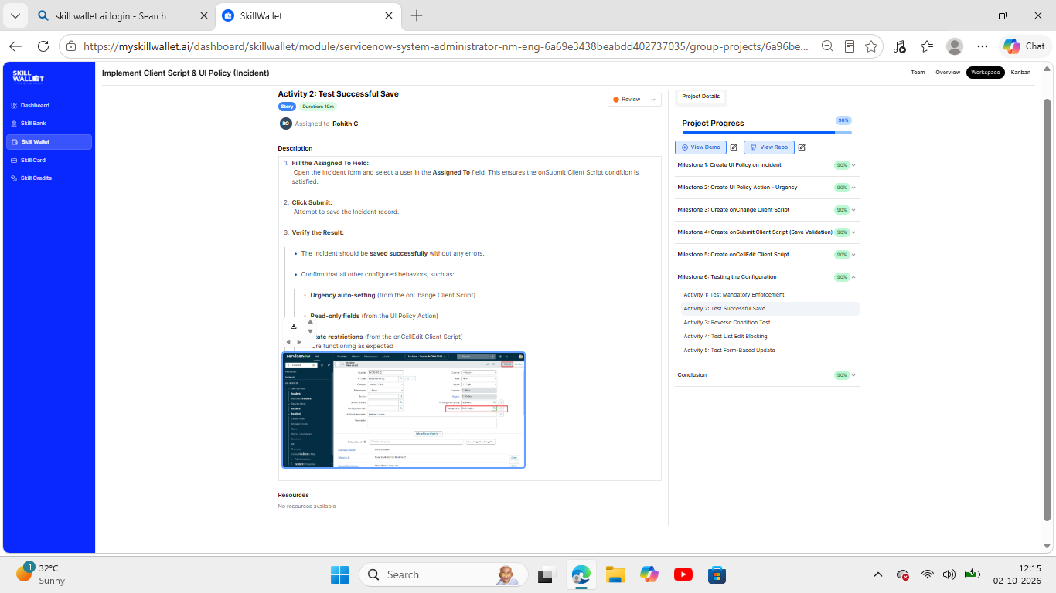  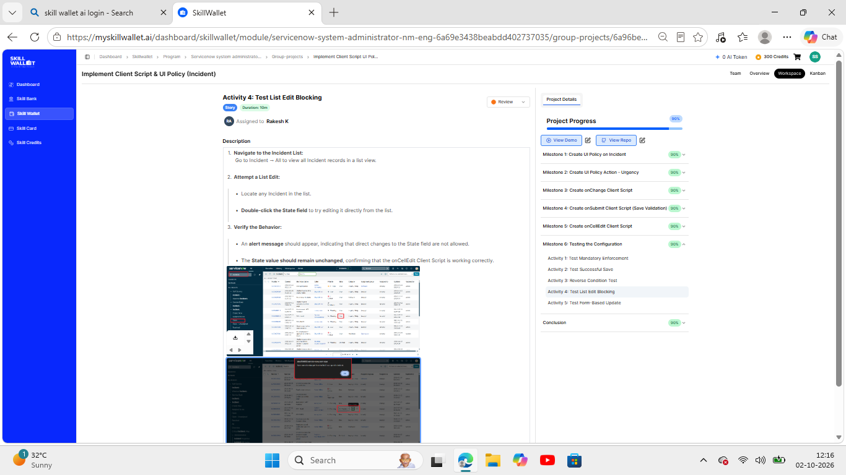
 | Data Preprocessing | Not applicable – no data import, cleaning or transformation is used; the data is native ServiceNow Incident records. Equivalent data handling is done on the client side: the onChange script auto-sets Urgency when Impact changes, and the onSubmit script validates that Assigned To is filled before an incident is saved.
3. | Utilization of Data Filters | No report filters are used. Equivalent conditions: the UI Policy "High Impact Control" on the Incident table applies only when Impact is 1 – High (Reverse if false = true), and the Incident list is opened via All incidents.  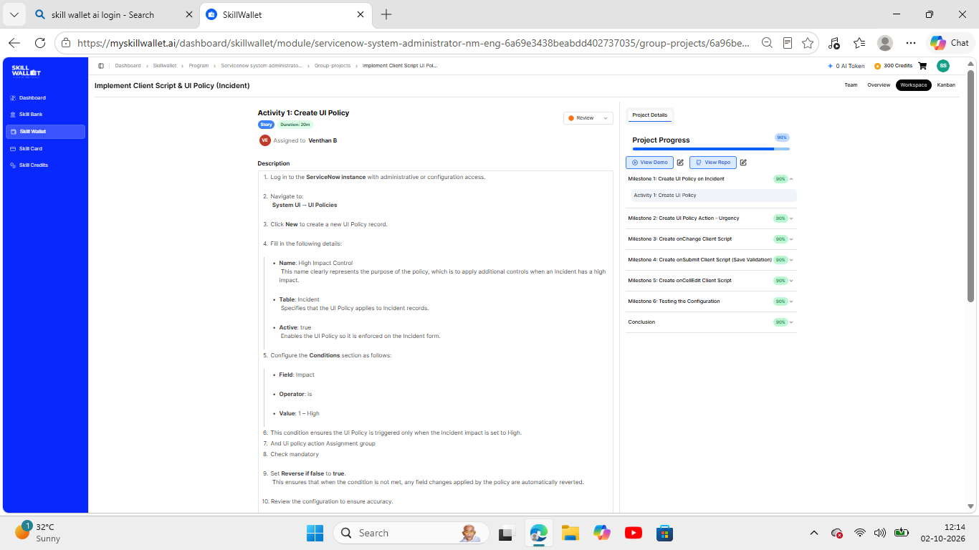
4. | DAX Queries Used | Not applicable – no DAX is used because the project does not include Power BI. Equivalent logic is written as three Client Scripts: onChange (Impact → Urgency auto-set with an info message), onSubmit (Assigned To mandatory for High impact, error message on save) and onCellEdit (blocks State edits from the list view with an alert).  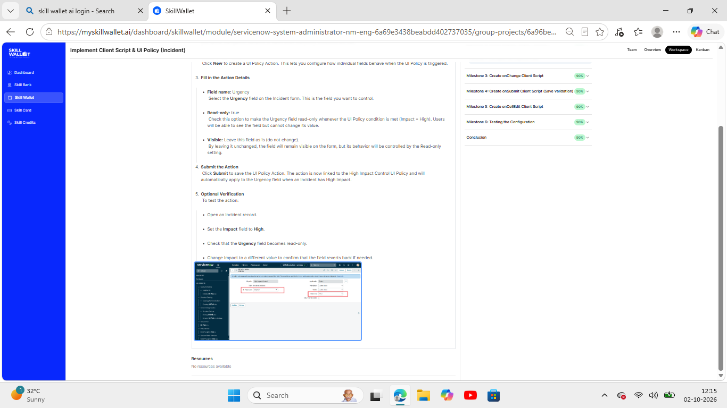
5. | Dashboard design | No of Visualizations / Graphs - 0. No dashboard was built; the project is a form-behaviour configuration (UI Policy and Client Scripts) on the Incident form.
6 | Report Design | No of Visualizations / Graphs - 0. No report was built; results are validated through the five test activities in Milestone 6 (Testing the Configuration).

